Project Name: PokeMario  
Members:

Ayush Jha 21057

Samyak Jain 21058

Jayati Trehan 21102

Synopsis:

This game is inspired by the old school Nintendo games such as Pokemon, Contra and Super mario.

The player goal is simple: to solve puzzles and defeat enemies to unlock the next level and as the game progresses the levels get harder and harder with puzzles that gets trickier. The player has to think twice before making a move or else he’ll lose the only life that is being given to him. To make the game even harder the player will have only one life so every move is crucial for the game. Players need to Outsmart quirky enemies inspired by iconic Pokemon and battle bosses based on Contra's menacing foes. Collect scattered pixels to gain points and set a highscore.

The levels are not time bound, the player can take as much time as possible. To the make the game more challenging if a player loses a life at any level for example. If the player is at level 4 and he loses his only life given to him to an enemy the game will start all over it again and no progress is saved except his/her highscore.

Technical Overview:

The game loads up a screen with the home screen, on which the name of the game is written, and there is a button “Start” to start the game, and a sound effect on/off toggle.

If the player clicks on “Start” button, the screen changes and it takes it you to the first level of the game . If the player defeats all the enemies the door for the next level opens up and player proceeds to the next level.

If the player runs out of live, a “Game Over” screen comes up with the following buttons: “Try Again”, “Main Menu” and “Quit”. If the player selects the “Try Again” option he will start the game from the first level again.

If the players completes all the level successfully, a “You Win” screen comes up with the following buttons: “Play Again”, “Main Menu” and “Quit”.

Software Details:

Programming language Python 3.x will be used, along with its libraries like : pygame, pyglet

Some sample screenshots of 2D platformer games are:

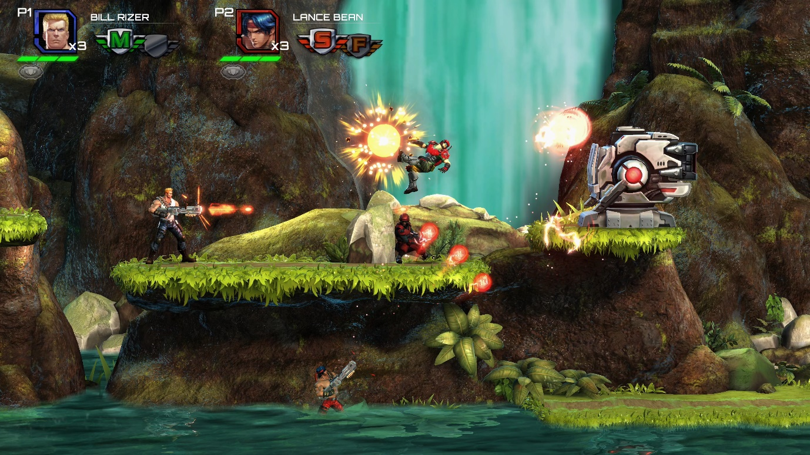

CONTRA

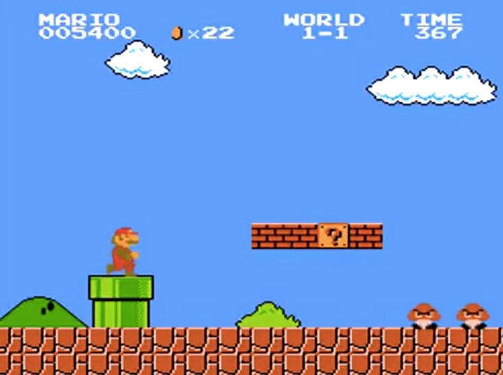

SUPER MARIO BROS 1985

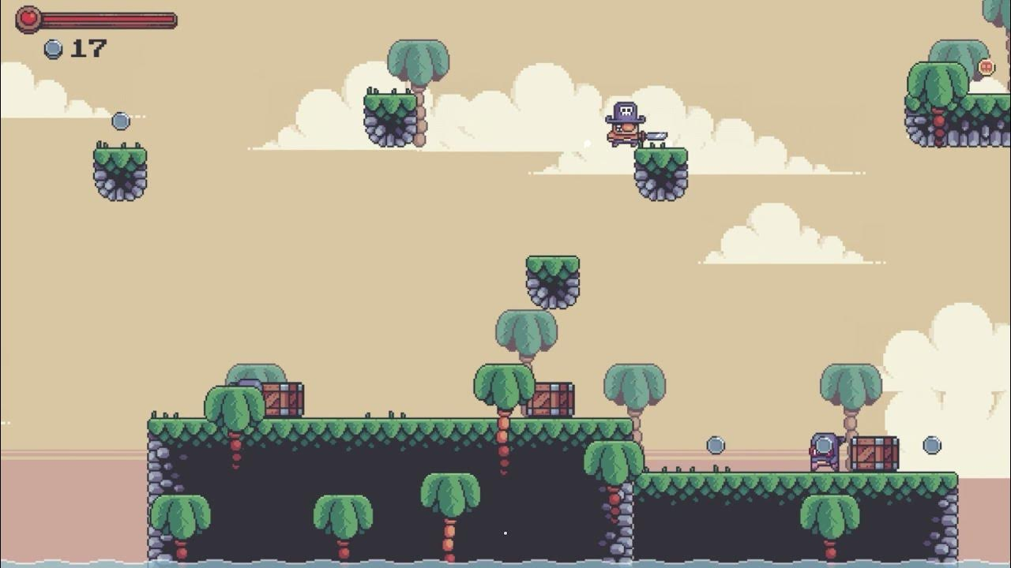

2d platform game